**Project Name – Easy Library Management**

**INTRODUCTION**

* Library Management System is designed to make the everyday working of the library very easy and simple. It can be done wherever we are by just using the Software. It keeps track of issued, returned, added books in the library.
* In Librarian Login Librarian can add new student, add new book, issue the book, submit the book, delete the book, delete student, search for any book and can see the list of issued, books.
* Librarian can Generate Barcodes for Book as well as Student to simplify his or her work at the time of issuing or returning book by scanning barcode using Barcode Scanner Machine.

**SOFTWARE REQUIREMENT :**

* Java Version 8 or Above and MYSQL.

**SOME SCREEN SHOTS**

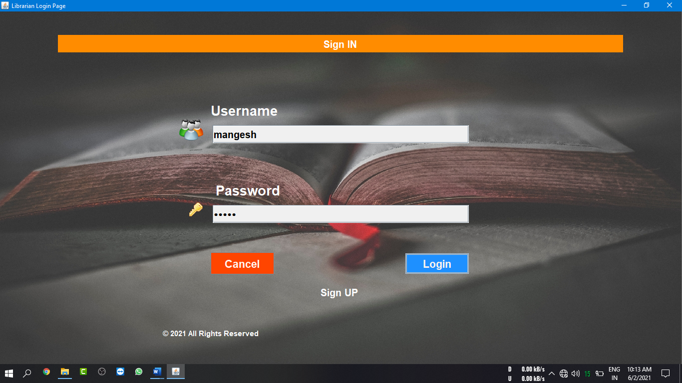**Login Frame :**

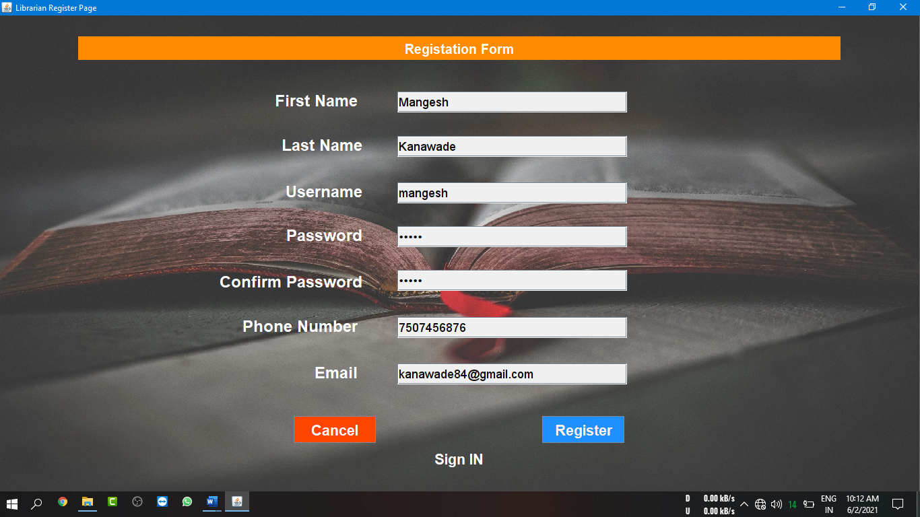**Sign Up Frame :**

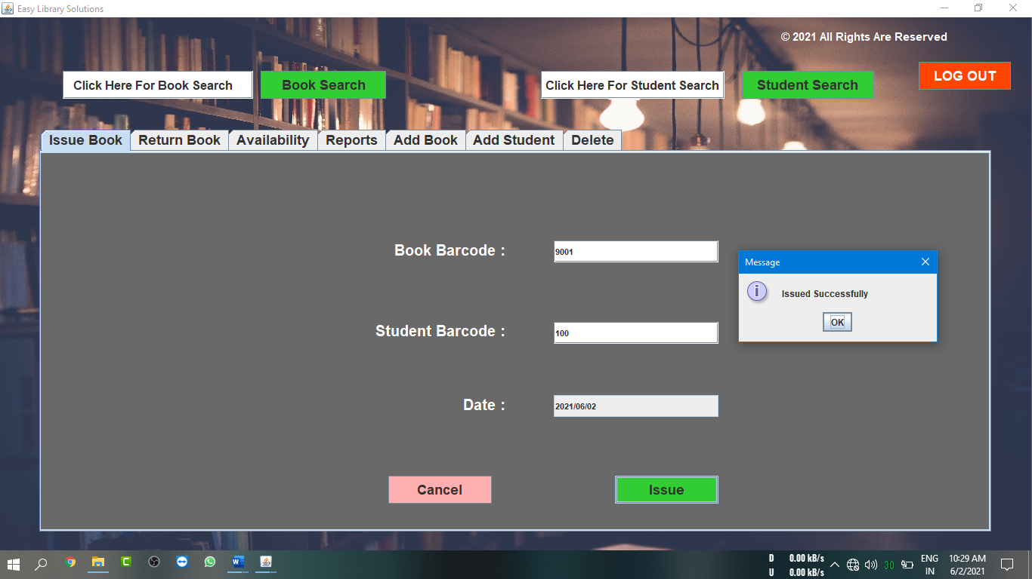**Issue Book Panel :**

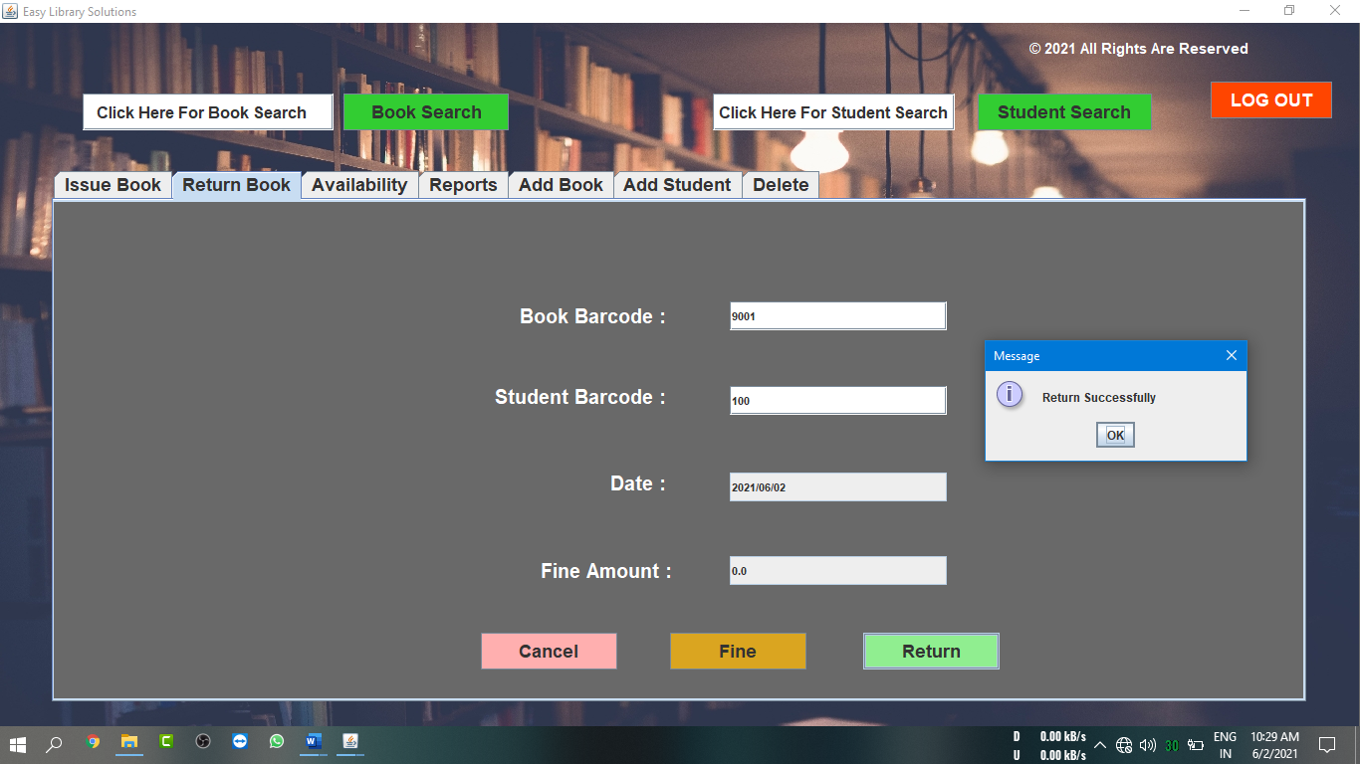**Return Book Panel :**

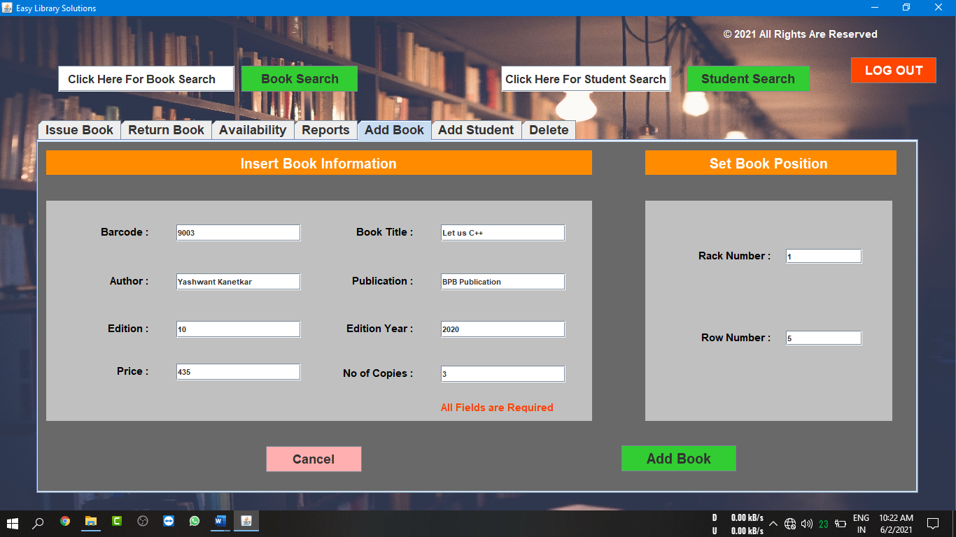**Add Book Panel :**

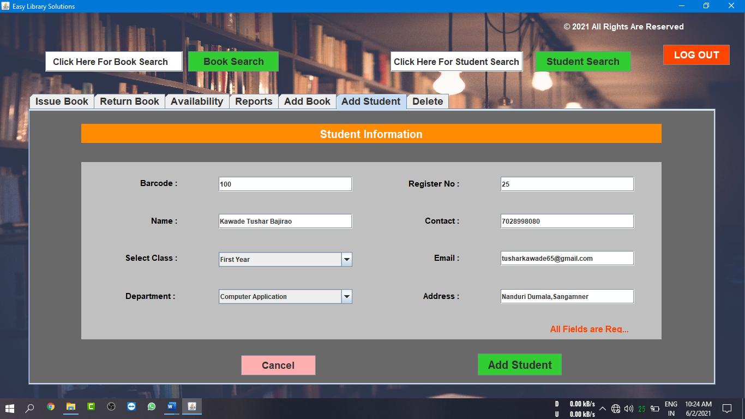**Add Student Panel :**

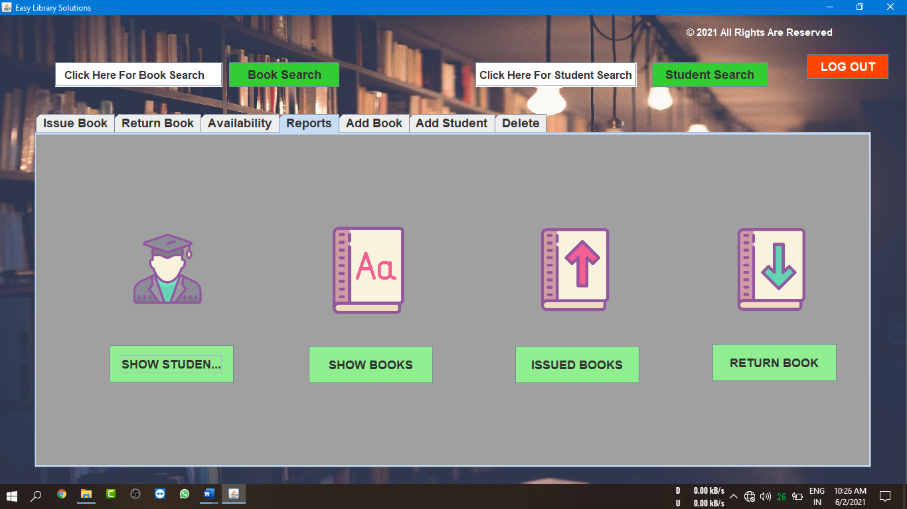**Reports Panel :**

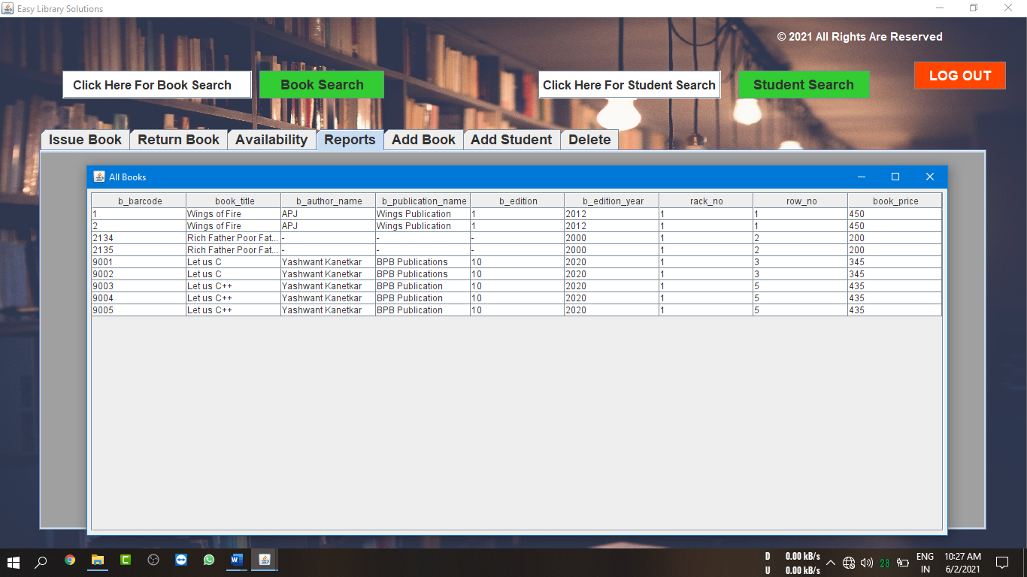

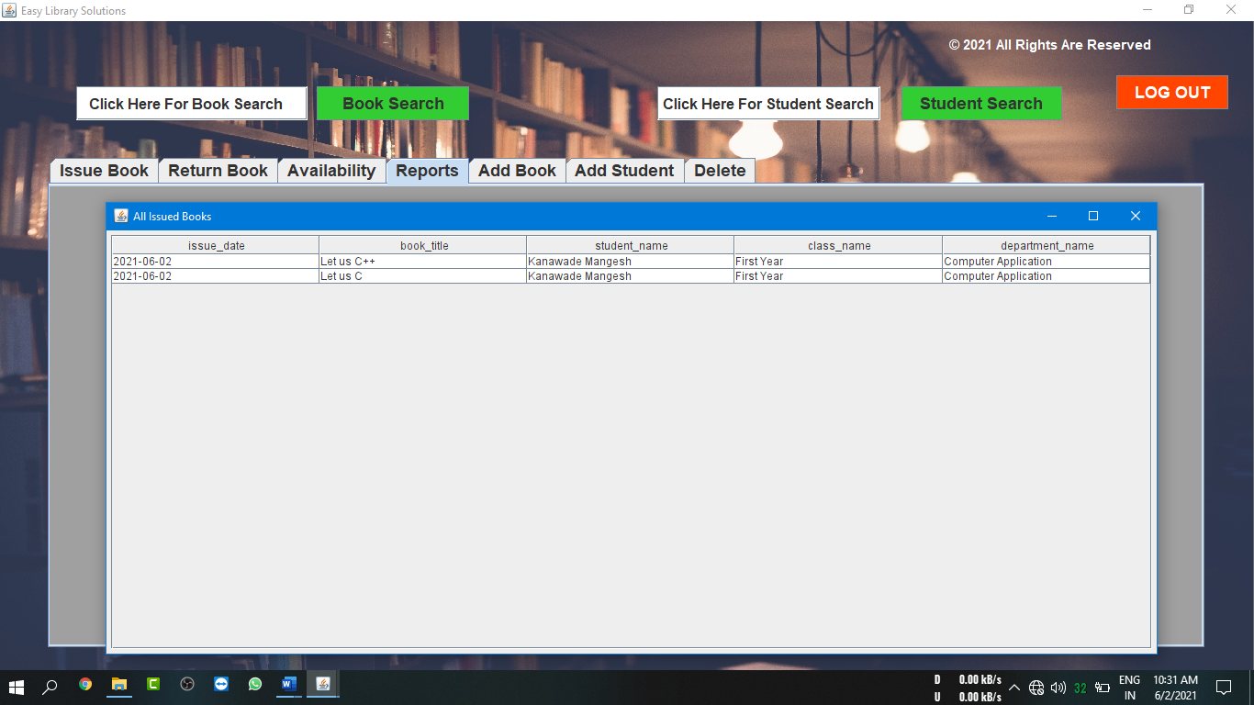

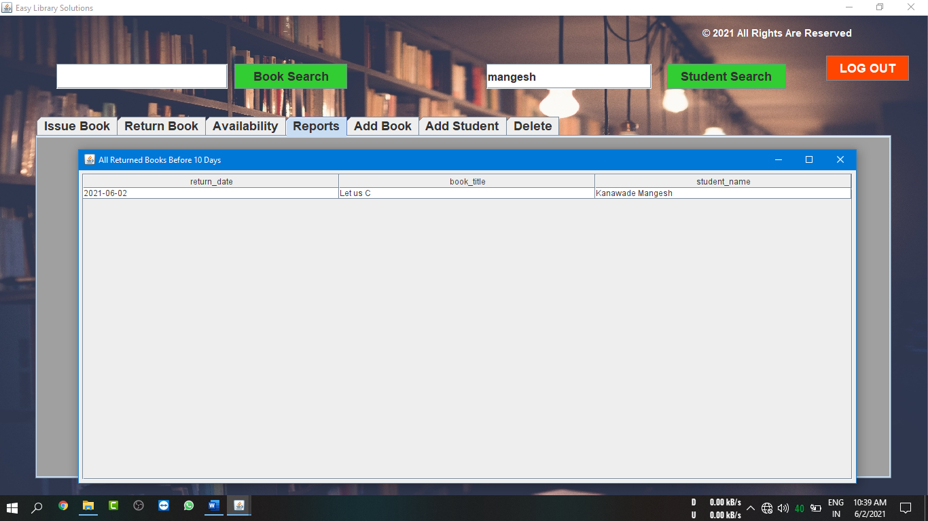



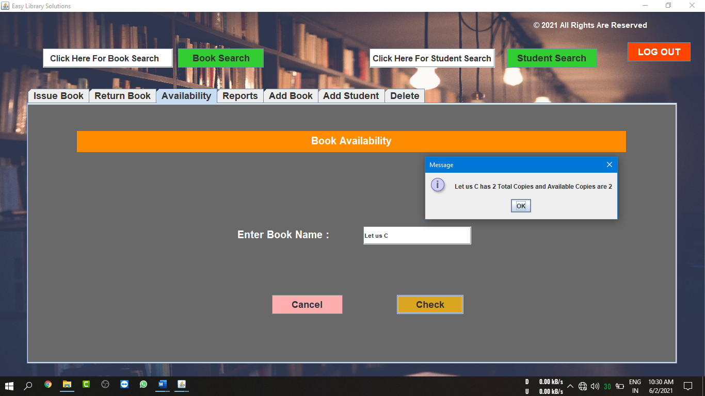**Book Availability Panel :**